Computer Programing Using Python 2.7 - **Panda 3** page 1of2 **- Making a Terrain: Height Map**

**GOALS: Create a Heightmap and Color map and load it in Panda so panda creates a terrain.**

To create a terrain, you can use two pictures—one for height, and one for color.

A heightmap can be used to generate a 3D landscape:

|  |  |
| --- | --- |
| http://upload.wikimedia.org/wikipedia/commons/5/57/Heightmap.png  **Paint this (top view height map, like an elevation map)** | File:Heightmap rendered.png  **Then Panda3D can generate this 3D version automatically from your painting** |

Using GIMP, a free GPL (general public license) program from gimp.org, you can create these files.

GIMP menu is customizable, so if you lose any options, click Edit, Preferences, Window Management, Reset, then restart GIMP.

Create a folder for your textures

* Start, Computer, H:
  + Click *once* on Panda1 folder, then click “Copy this folder”
  + Create a new folder called *textures*

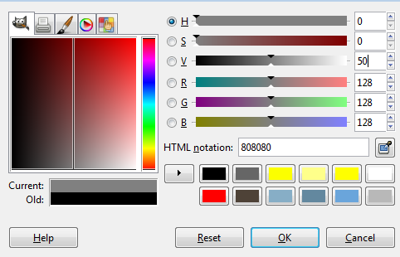Create a heightmap in GIMP and save it in your textures folder

* Start, All Programs, GIMP, GIMP
* File, New, 513x513 px
* On left tool panel, click the bucket fill tool:  or press Shift B
* Choose a medium gray (50% value)
* 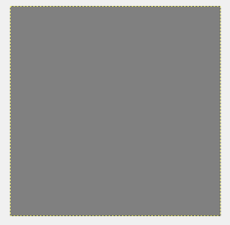Click OK, then click on the image to fill with gray:
* Click paint brush tool on left
* To change the height a little bit at a time,
* change opacity to about 50%:
* Click Brush preview to change brush shape to something other than circle or square
* 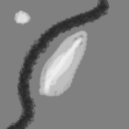Paint white to make **mountains** & Paint black to make valleys or rivers from a top view like you are drawing a map (see pic):
* Must have at least two **mountains** and one **valley** (or a total of 3 features in other combination)
* File, Export (if your version of GIMP does not have Export, instead click File, Save As, then Browse for Folder)
  + Click Computer, H:
  + Double-click your *panda1* folder
  + Create folder, name the new folder *textures*, then press enter
  + Name it height.png

(seniors are finished here)

Computer Programing - Unit 3 Panda 3D with Netbeans - **Panda 3** page1of2**: Making a Terrain: Color on New Layer**

**Make Color map:**

Make sure you are done Panda 3.1 and have height.png saved

GIMP, file open, your home drive, H:\panda1\textures\height.png

Layer, New Layer, for Layer Fill Type, choose Transparency, OK

On left tool panel , click the paintbrush tool [TIP: if missing panels, click Edit, Preferences, Window Management, Reset]

For each part, choose a color then paint **over each** so each is the **correct color**

Such as: valley is dark green or dark brown, mountain is light green, or gray, and rest is green (or light brown)

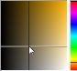[TIP for if you want brown: click color swatch  then choose orange on bar (hue, on right) then on square (brightness/saturation) click nearer to gray: ]

Make sure there is no more gray showing when you’re done

**Save Project File with Layers:**

File, Save As, your home drive, H:\panda1\textures*terrain.xcf* (XCF is a GIMP project file that can store both layers in one file but cannot be used by panda—it is only saved for if you want to edit the picture in the future)

**To save the top layer (color of terrain) as image:**

File, Export to (if you don’t have export, instead click Save As, Browse for more folders, then) your home drive, H:\panda1\textures*grass.png*

**Now make your program use the terrain height and color:**

* Make sure Python for NetBeans is installed (if NetBeans has no Python, then Python will not be listed in Tools menu of NetBeans). If not, close NetBeans, run S:\Profiles\Default\NetBeans-restore.bat, wait until finished
* Open NetBeans
* File, Open Project, H:\Panda1
* Expand the project so you can see your files (click ‘+’ plus sign  by each item until you can see all files): 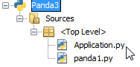 (it is ok for your project to be called Panda1 if you used the same folder)
* Double-click Application.py to edit your application
* To be able to use the GeoMipTerrain object, go to the top of the Application file add the following line:



* First make the camera higher so it will be above the terrain. Find your camera.setPos call and change it to:



* After that line load the terrain and convert it to 3d using the code below (indented the same way so that it happens during Application initialization):

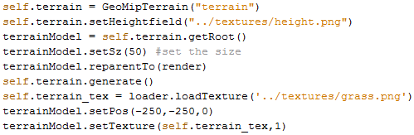

* Run, Run Project. If it works, you should be able to drag the middle button (hold down scroll wheel and move whole mouse) to look around! (Lang 33)